ESG Focused GenAI Research

Project Overview

How to leverage GenAI and its derived tools with prompt engineering to enhance and increase the efficiency of environmental, social and governance (ESG) dashboard analysis from a portfolio management perspective. Objectives: 1) To identify how prompt engineering may impact question-answering AI outcomes, researching on embedding methodologies. 2) To build a GenAI tool to explain and elaborate ESG reporting results with ESG domain knowledge/data incorporated. Both raw and aggregated data will feed into the tool to conduct analysis on; Sample analysis/questions below. 3) To establish guidance for end users (data science teams, investment teams) on how to develop and apply AI application for ESG portfolio research.

**Research question:**

How to leverage GenAI and its derived tools with prompt engineering to enhance and increase the efficiency of environmental, social and governance (ESG) dashboard analysis from a portfolio management perspective.

**Objectives:**

1. To identify how prompt engineering may impact question-answering AI outcomes, researching on embedding methodologies.
2. To build a GenAI tool to explain and elaborate ESG reporting results with ESG domain knowledge/data incorporated. Both raw and aggregated data will feed into the tool to conduct analysis on; Sample analysis/questions below.
3. To establish guidance for end users (data science teams, investment teams) on how to develop and apply AI application for ESG portfolio research.

**Project plan:**

1. Gather financial and ESG data from Bloomberg, public internet sources etc., to create a representative dataset.

Sample data format:



the market value of a company in comparison to its capitalization - A higher EV/MC ratio typically indicates untapped growth potential, while a lower ratio implies more value concentrated in the company’s equity.

1. Build LLM data pipeline and model to ingest and analyze the dataset.
2. Utilize model to test and conduct analysis on dataset to answer the following sample questions:

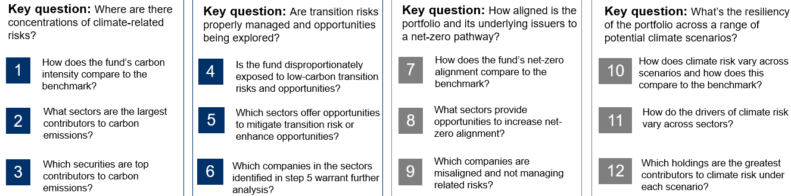

1 -> aggregated metric, (weighted average at the fund level at portfolio level and comparison with benchmark)

What are the top 10 and bottom 10 names for this metric

1. Review results with stakeholders and refine model as needed.
2. Document all operational processes, researcher decisions, user/analyst instructions; This will be used as a framework or ‘instructions manual’ to deploy the tool to live data and to be leveraged for future builds based off this tool.
   1. Make it as user friendly as possible
3. Code interpreter

**Data Sources:**

1. Queen's Bloomberg data
2. Public internet such as seeking alpha or public ESG documents
3. Encrypted data from RBC CGRI team - to be confirmed